Closing Disclosure Explainer

Use this tool to double-check that all the details about your loan are correct on your Closing Disclosure. Lenders are required to provide your Closing Disclosure three business days before your scheduled closing. Use these days wisely—now is the time to resolve problems. If something looks different from what you expected, ask why.
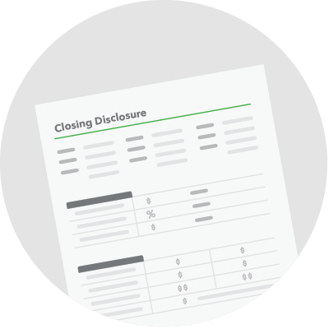

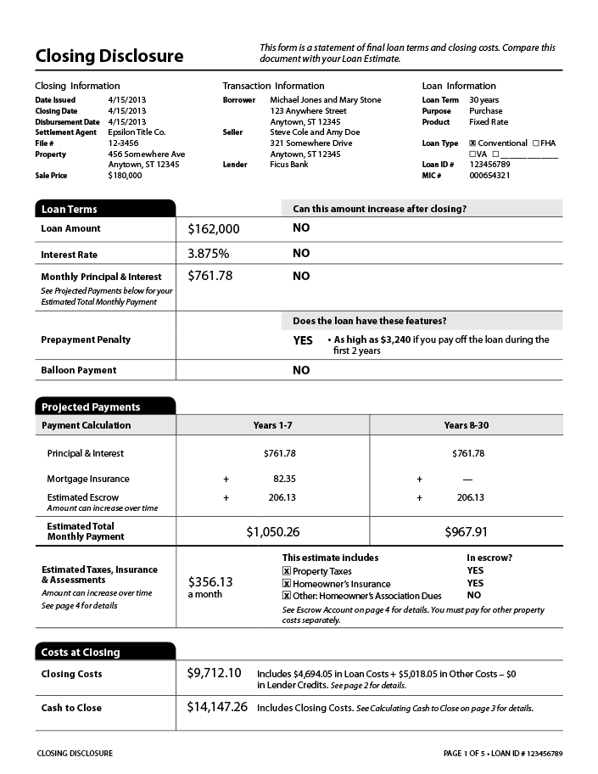
Check the spelling of your name. Ask the lender to correct any inaccurate contact information. Even minor misspellings can cause big problems later.

Check that loan term, purpose, product, and loan type match your most recent Loan Estimate. It's very important these items match what you were expecting. If they don't, call your lender immediately and ask why they have changed.

Check that the loan amount matches your most recent Loan Estimate. If it has increased, ask your lender why. A possible reason could be that closing costs have been rolled into your loan. This reduces your upfront costs at closing but adds to your overall costs because of the added interest you will pay.

Check your interest rate. If your interest rate isn't what you were expecting, ask your lender why. If you locked your rate, your lender is only allowed to change it under limited circumstances.

Does your loan have a prepayment penalty? This feature is risky. If your loan includes a prepayment penalty, learn more and ask your lender about your other options.

Does your loan have a balloon payment? This feature is risky. If your loan includes a balloon payment, learn more and ask your lender about your other options.

Check that your Estimated Total Monthly Payment matches your most recent Loan Estimate. Make sure you can comfortably afford to pay the Estimated Total Monthly Payment every month. If this number doesn't reflect what you were expecting, ask your lender why it has changed.

Check to see if you have items in Estimated Taxes, Insurance & Assessments that are not in escrow. If so, have you budgeted to pay for these costs separately?

Check that your Closing Costs match your most recent Loan Estimate. If there are significant changes in your closing costs, ask your lender to explain why.

Check that your Cash to Close matches your most recent Loan Estimate. If not, ask your lender to explain why.

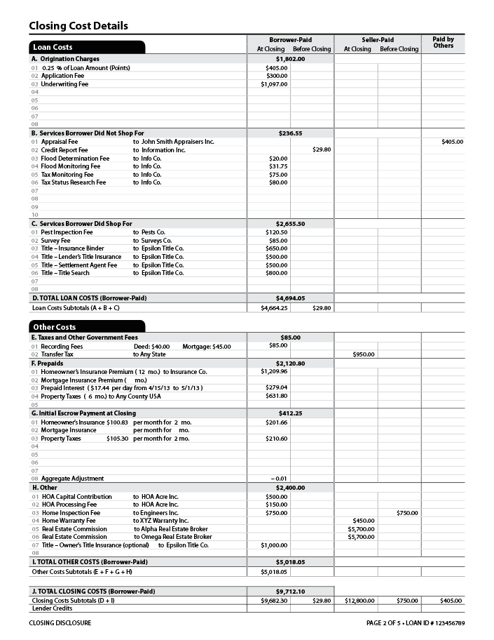 | Check that “Services Borrower Did Not Shop For” are similar to what was shown on your Loan Estimate. These are third-party services required by your lender in order to get a loan. Compare with Section B, “Services You Cannot Shop For” and Section C, “Services You Can Shop For” on page 2 of your Loan Estimate form. Check to see that, overall, there are no new services listed that were not on your Loan Estimate form. The costs should be similar but may be somewhat different from what was on your Loan Estimate form.  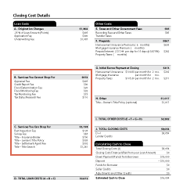

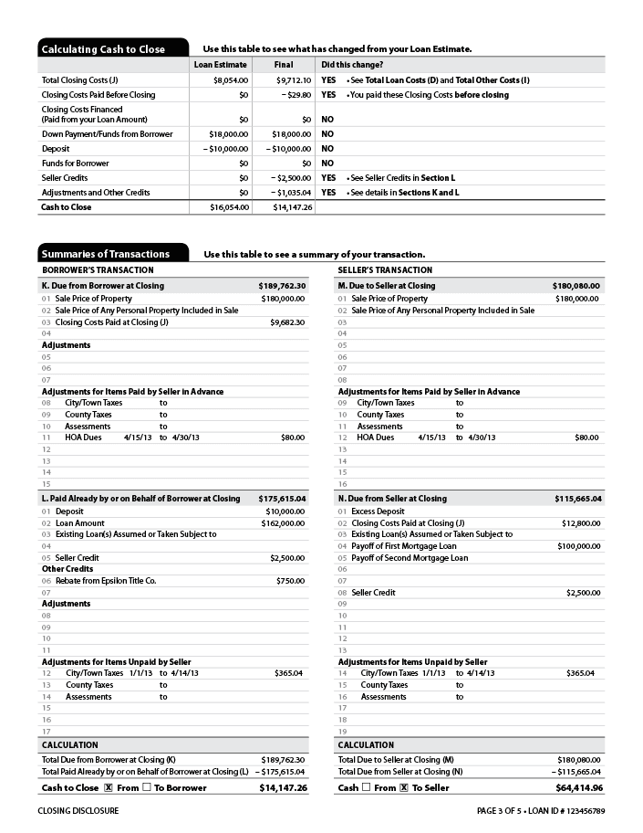 | Check that your Seller Credit reflects what you agreed upon with the seller. This is the amount the seller has agreed to contribute to your closing costs. If the seller has agreed to pay for specific costs rather than contribute a general amount, those amounts may be listed as “Seller Paid” line items on page 2 instead.

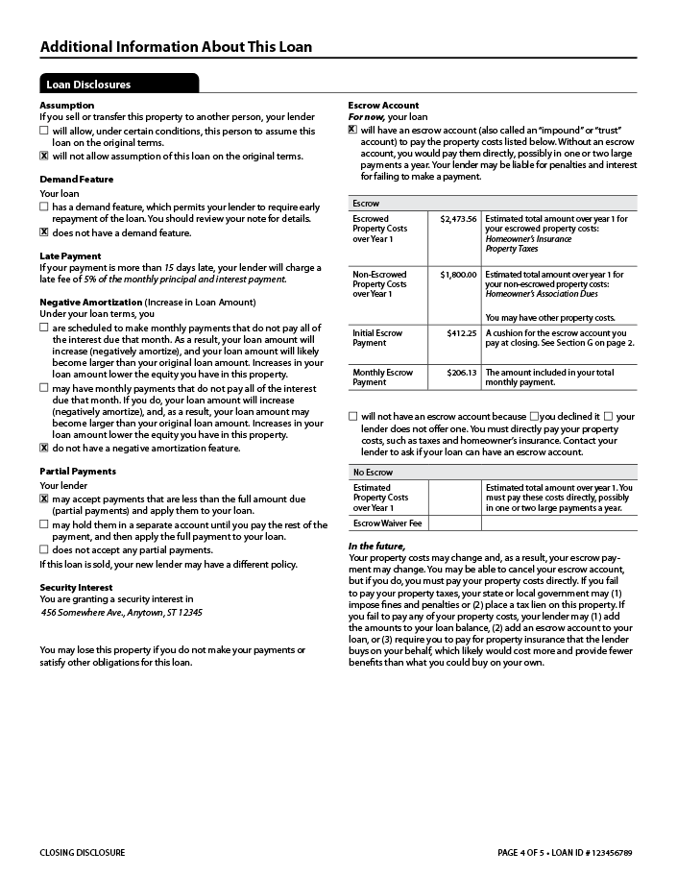 | How much will it cost if you make a late payment? It’s important to make your mortgage payments on time and in full, every month, to avoid fees and improve your credit record. However, it’s good to know in advance how much the fee will be if your payment is late.  Will your lender accept partial monthly mortgage payments? If you are unable to make the full mortgage payment in a given month, your lender may not accept a partial payment. Even if the lender accepts partial payments, the lender may hold them in a separate account instead of applying them to your loan. The lender may also charge you a late fee every month until you make up the difference. The lender may also report you to the credit reporting agencies as not making your required payment. Ask questions so you understand exactly what happens if you can’t make a payment in full.  Will you have an escrow account? Many homeowners pay their property taxes and homeowner’s insurance as part of their monthly payment. This arrangement is called an escrow account. This section tells you: whether you have an escrow account, which homeownership expenses are included in the escrow account, and the estimated costs. Ask questions so you understand exactly what is included in the escrow account and what isn’t. For example, homeowner’s association fees are often not included in the escrow account.  If your Closing Disclosure shows that you don’t have an escrow account, but you would prefer to pay your property taxes and homeowner’s insurance monthly instead of in one large lump sum, talk to the lender.  If you do not have an escrow account, are you paying an escrow waiver fee to the lender? Some lenders may charge a fee if you choose not to have an escrow account. Did you discuss this choice with your lender? If your Closing Disclosure shows an escrow waiver fee and you would prefer to pay your property taxes and homeowner’s insurance monthly into an escrow account instead of paying this fee, talk to the lender.

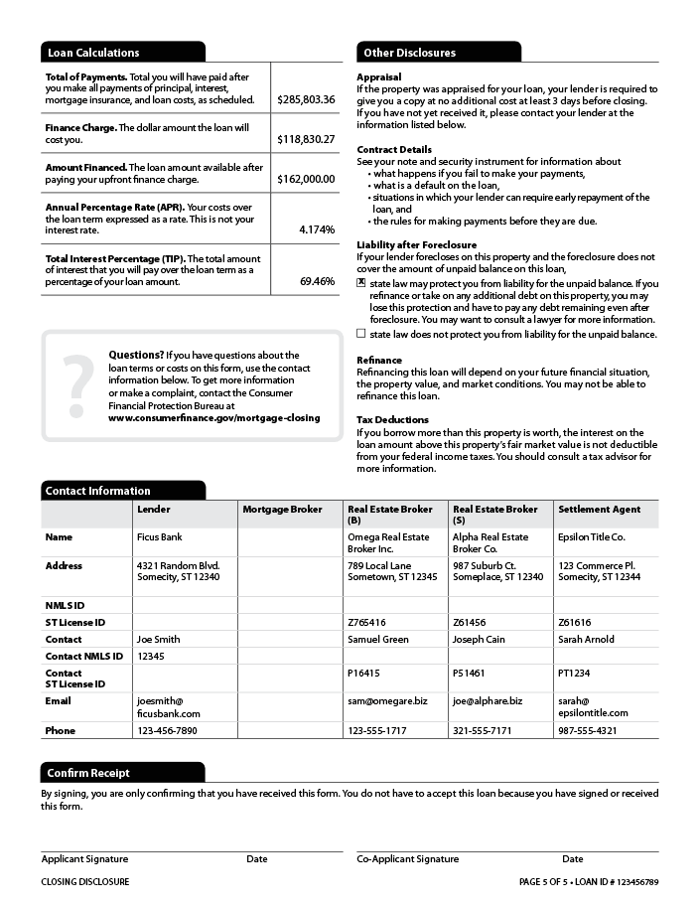 | Contract Details. It's important to read your note and security instrument (also known as the “mortgage” or “deed of trust”) carefully.

